

Castle Crasher Activity

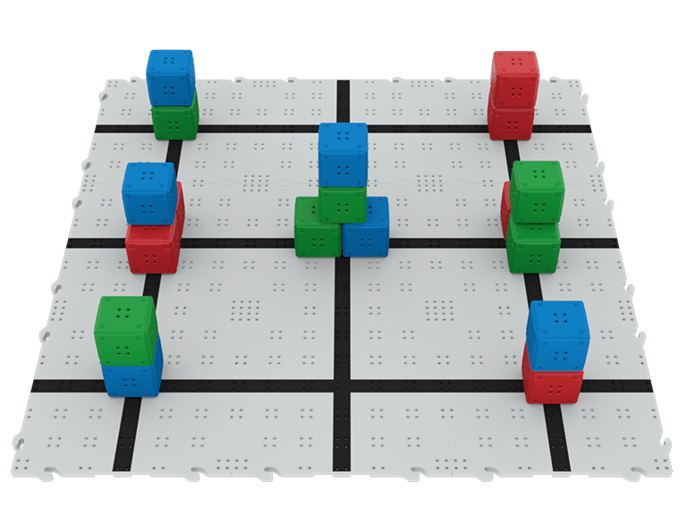 | Drive your robot to knock over castles and clear all the Cubes from the Field as quickly as possible!

Challenge Goal: Knock over all of the castles and clear the Cubes from the Field as quickly as possible!
- A Cube counts as cleared when it is no longer touching the Field.

Set Up and Rules:
- Complete the challenge using your VEX IQ robot and the built-in Driver Control Program.
- Your robot starts in the same location every time.
- If your robot falls off the Field, stop driving and try again.
- Reset the castles before each run.
- Take turns driving the robot.

Drive Mode Reminders
 | Left Arcade  Drive forward, reverse, left, and right using only the left joystick.
 | Right Arcade  Drive forward, reverse, left, and right using only the right joystick.
 | Split Arcade  Drive the robot left and right using the left joystick, and forward and reverse using the right joystick.
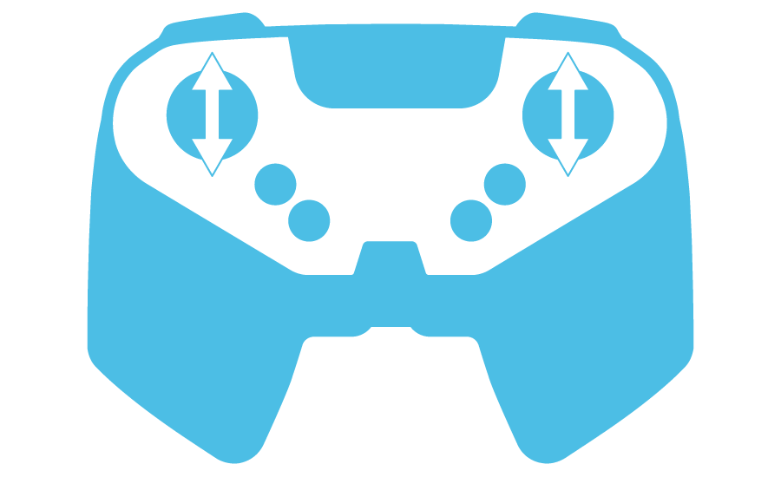 | Tank Drive  Drive the robot's left motor using the left joystick, and the right motor using the right joystick.

Castle Crasher
Activity Notes

Hands-on time for this activity is approximately 1 hour.

Preparing for the Activity

Additional materials needed for each group:(recommended group size is two-three students):
- Pre-built VEX IQ BaseBot or Speed Build
- 3 x 3 Field (without walls), or a taped-off 3-foot square space
- 18 Cubes (any color) to build castles
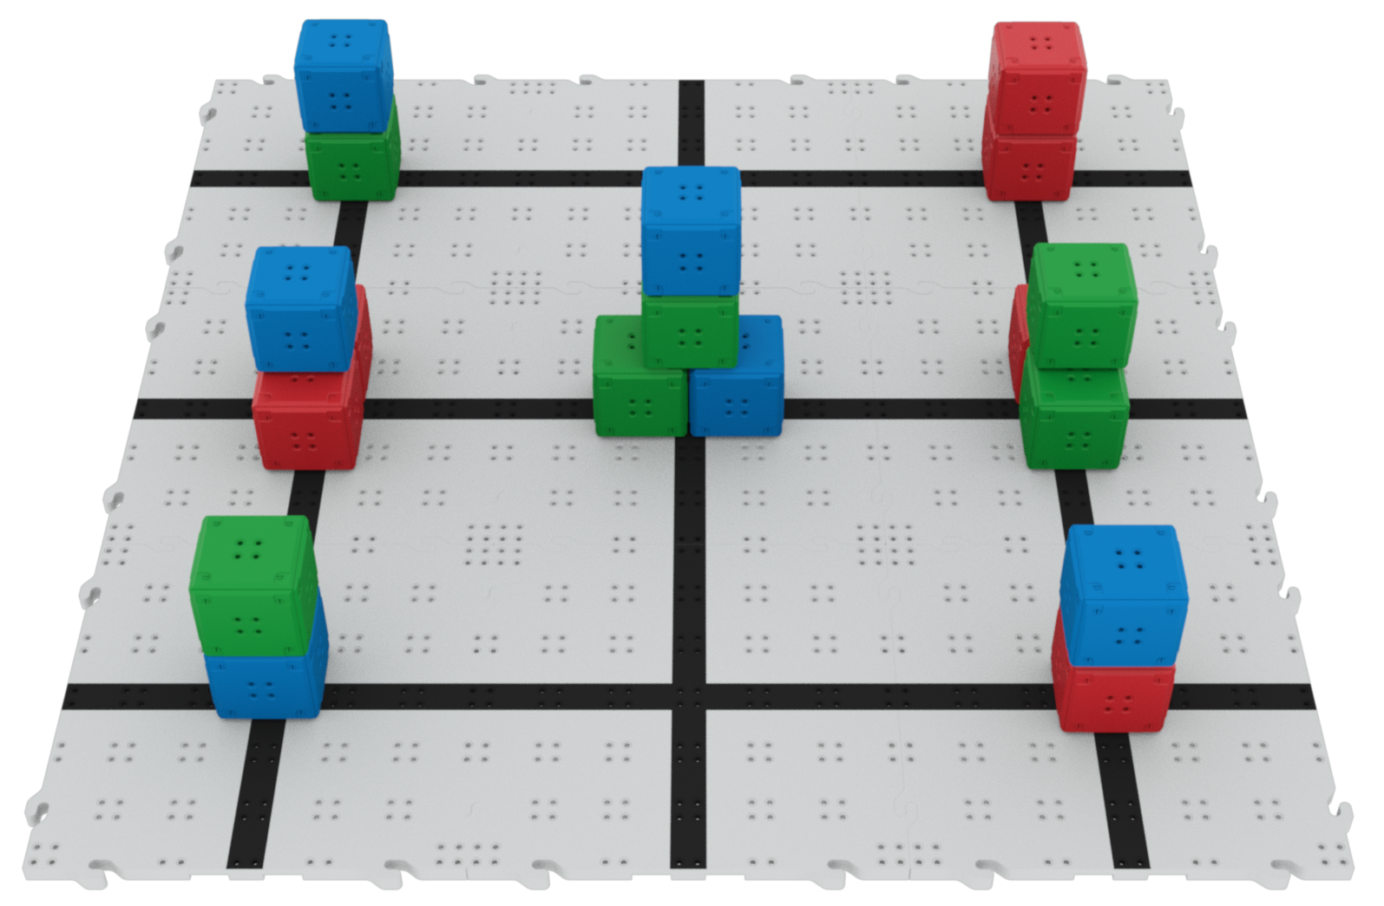
- Tape or wet erase markers and a damp cloth for marking locations on the Field

Set Up the Field As Shown:
- Build “castles” of 2, 3, or 4 Cubes around the Field.
- Leave approximately 6 inches of space around each side of the Field. This will allow space for the Cubes to be pushed off the Field.
- Mark the robot and the castles' starting locations with tape or a wet erase marker so the Field can be easily reset between turns.

Facilitating Castle Crasher

- Introduce the activity. Share the context here to help students connect what they will do with the robot to real-world applications.
 | Robotics challenges can look simple at first: drive forward, turn, hit the target. But once the timer starts, engineers quickly discover that small decisions can make a big difference. In Castle Crasher, your team will take on a robotics challenge with clear constraints: a Field to navigate, Cube castles to knock over, and a limited amount of time to clear as many Cubes as possible. To succeed, you will need more than driving skill. You will need a plan, communication, and a willingness to adjust your strategy based on what you learn.  As you work, focus not only on what your robot does, but on how your team solves problems together. Share ideas, test strategies, learn from each run, and look for ways every team member can contribute.

- Introduce how to drive the robot using the Driver Control Program. Walk students through the steps to begin driving the robot. Use this article for reference.
  - Have students explore the different ways the robot can move using the joysticks and controller buttons.
  - Show them how to change the Drive Mode on the IQ Brain.
  - Give them time to practice driving in a square to try out each of the different Drive Modes. They do not need to drive on the fields - driving on the floor is fine for this part of the activity.
  - Bring students together to check for understanding using the following prompt:
    - Which Drive Mode was most comfortable for you? Why?

- Direct students to start the Castle Crasher activity:
  - Move around the room and talk with students, asking questions like:
    - What strategy are you using to clear the castles?
    - How is your driving improving as you practice?
    - What have you noticed about controlling the robot that is helping you to drive more accurately?
  - Students should take turns driving the robot. One student can reset the Field while the other keeps track of timing and the number of castles and Cubes cleared.
  - Encourage students to talk through their driving strategy, and to try to improve their time or the number of castles cleared with each run.

Extending the Activity

- Have students build the robot as part of the workshop. Allow approximately 30 minutes for groups to build the BaseBot or Speed Build.
- Have students communicate their path and/or strategy before they drive. You can use tape or wet erase markers on the Field, or use this printable to document the path and any strategy notes.
- Create a workshop challenge! Have a friendly competition to see which group can clear the castles the fastest! You can use the IQ Leaderboard to keep track of students’ progress in a central location.
  - You can have groups nominate a driver for the competition or take the cumulative time of the whole group.
- Complete the activity with VEXcode IQ. Students can access VEXcode IQ using the application or via a Chrome browser at codeiq.vex.com. (Note: students will need a computing device to use VEXcode IQ.) See the VEXcode IQ section of the VEX Library for more information.

